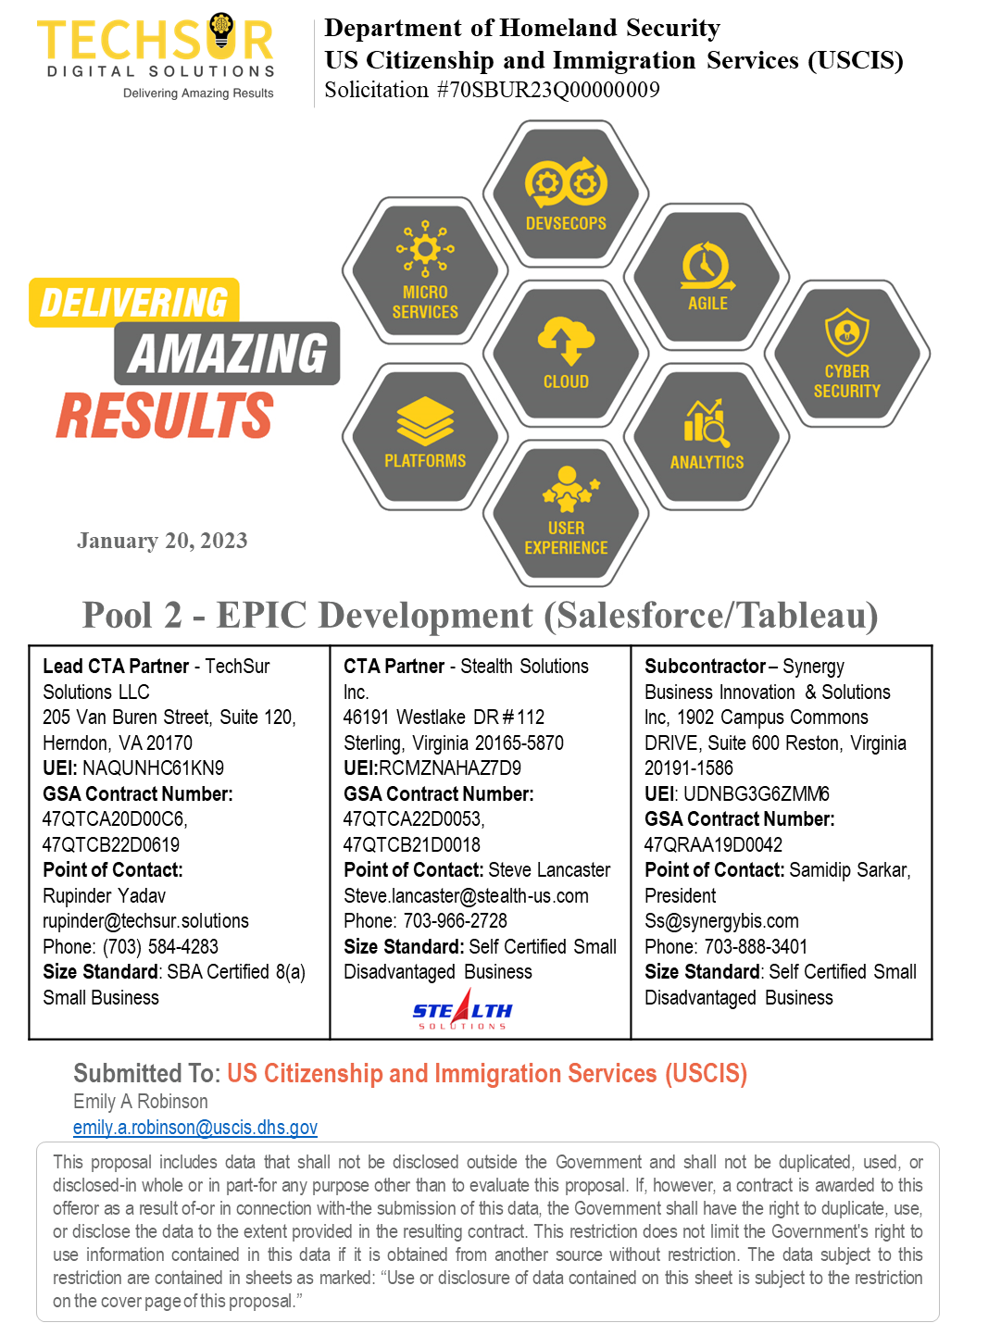

Enterprise Platform for Integrated Citizen Development (EPIC)

Table of Contents

1.0 Acceptance of Amendments 1

2.0 Organizational Conflict of Interest 2

3.0 Exceptions 4

4.0 Teaming Arrangement 5

5.0 Additional Information 6

5.1 Representation and Certification 6

# Acceptance of Amendments

Team TechSur - Stealth acknowledges and accepts any and all amendments associated with RFQ 70SBUR23Q00000009, amendment 0001 dated 01/12/2023 and amendment 0002 dated 01/19/2023.

# Organizational Conflict of Interest

**Responses to applicable clauses or provisions such as HSAR 3052.209-72 Organizational Conflict of Interest (JUN 2006)**

Team TechSur - Stealth hereby represents to the best of its knowledge that it is not aware of any facts which create any actual or potential organizational conflicts of interest relating to the award of this contract. We are submitting the Phase 1 proposal only for development services.

**DEPARTMENT OF HOMELAND SECURITY ACQUSITION REGULATION (HSAR) PROVISIONS INCORPORATED IN FULL TEXT**

HSAR 3052.209-72 Organizational Conflict of Interest (June 2006)

(a) Determination. The Government has determined that this effort may result in an actual or potential conflict of interest, or may provide one or more offerors with the potential to attain an unfair competitive advantage. The nature of the potential conflict of interest and the limitation on future contracting is providing both Citizen Development Governance services under this contract and providing current or future Development services for Citizen Development. The Government has determined that providing both Governance and Development services may impair a contractor’s objectivity.

(b) If any such conflict of interest is found to exist, the Contracting Officer may (1) disqualify the offeror (quoter), or (2) determine that it is otherwise in the best interest of the United States to contract with the offeror (quoter) and include the appropriate provisions to avoid, neutralize, mitigate, or waive such conflict in the contract awarded. After discussion with the offeror, the Contracting Officer may determine that the actual conflict cannot be avoided, neutralized, mitigated or otherwise resolved to the satisfaction of the Government, and the offeror may be found ineligible for award. Likewise, award of this contract may limit the contractor’s ability to perform or compete for existing or future contracts for Citizen Development services.

(c) Disclosure: The offeror hereby represents to the best of its knowledge that:

(1) It is not aware of any facts which create any actual or potential organizational conflicts of interest relating to the award of this contract, or

(2) It has included information in its proposal, providing all current information bearing on the existence of any actual or potential organizational conflicts of interest, and has included a mitigation plan in accordance with paragraph (d) of this clause.

(d) Mitigation. If an offeror with a potential or actual conflict of interest or unfair competitive advantage believes the conflict can be avoided, neutralized, or mitigated, the offeror shall submit a mitigation plan to the Government for review. Award of a contract where an actual or potential conflict of interest exists shall not occur before Government approval of the mitigation plan. If a mitigation plan is approved, the restrictions of this clause do not apply to the extent defined in the mitigation plan.

(e) Other Relevant Information. In addition to the mitigation plan, the Contracting Officer may require further relevant information from the offeror. The Contracting Officer will use all information submitted by the offeror, and any other relevant information known to DHS, to determine whether an award to the offeror may take place, and whether the mitigation plan adequately neutralizes or mitigates the conflict.

(f) Corporation Change. The successful offeror shall inform the Contracting Officer within thirty (30) calendar days of the effective date of any corporate mergers, acquisitions, and/or divestures that may affect this clause.

(g) Flow-down. The contractor shall insert the substance of this clause in each first-tier subcontract that exceeds the simplified acquisition threshold.

# Exceptions

Team TechSur - Stealth agrees to all clauses, terms, conditions as shown in this RFQ, all the amendments and attachments and not taking any exceptions for this contract.

# Teaming Arrangement

TechSur Solutions and Stealth Solutions have an executed CTA teaming agreement in Place. Synergy Business Innovation & Solutions, Inc. is our subcontractor with a maximum 20% of workshare.

**Size Standard**

**TechSur Solutions** – SBA certified 8a

**Stealth Solutions** - Self Certified Small Disadvantaged Business

**Synergy Business Innovation & Solutions** - Other than small business

**Percentage Distribution of Task order**

TechSur Solutions: 40%

Stealth Solutions: 40 %

Synergy Business Innovation & Solutions: 20%

# Additional Information

## Representation and Certification

(1) Annual Representations and Certifications. Any changes provided by the Offeror in paragraph (b)(2) of this provision do not automatically change the representations and certifications in SAM.

(2) The offeror has completed the annual representations and certifications electronically in SAM accessed through http://www.sam.gov. After reviewing SAM information, the Offeror verifies by submission of this offer that the representations and certifications currently posted electronically at FAR 52.212-3, Offeror Representations and Certifications-Commercial Products and Commercial Services, have been entered or updated in the last 12 months, are current, accurate, complete, and applicable to this solicitation (including the business size standard(s) applicable to the NAICS code(s) referenced for this solicitation), at the time this offer is submitted and are incorporated in this offer by reference (see FAR 4.1201), except for paragraphs Not Applicable.